Project 17-1: Sort Quarterly Report

User interface
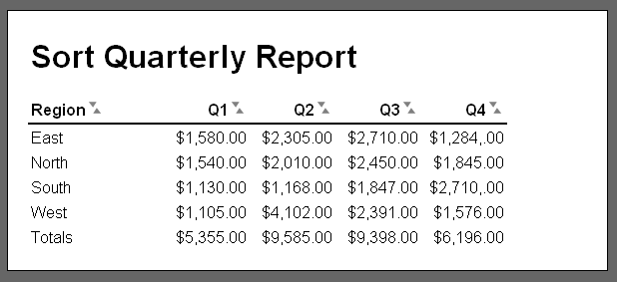

Operation
- This application sorts a quarterly report with a totals row.
- When the user clicks one of the sorting arrows, the rows of the table are sorted except for the header row and the totals row.

Specifications
- Add the totals row to the XHTML file.
- Use the jslib_dom_ready.js and jslib_event.js libraries from chapter 14 and the tablesort_library.js file from chapter 17.
- Modify the tablesort_library.js file to add a lastRow parameter to the constructor for the TableSort object type. When this parameter is set to false, the last row of the table is not sorted. Provide a default value of true for this parameter.
- Modify the remaining code in the tablesort_library.js file to implement the functionality of the lastRow parameter.
- Modify the report.js file to pass a value of false for the lastRow parameter to the TableSort constructor.

